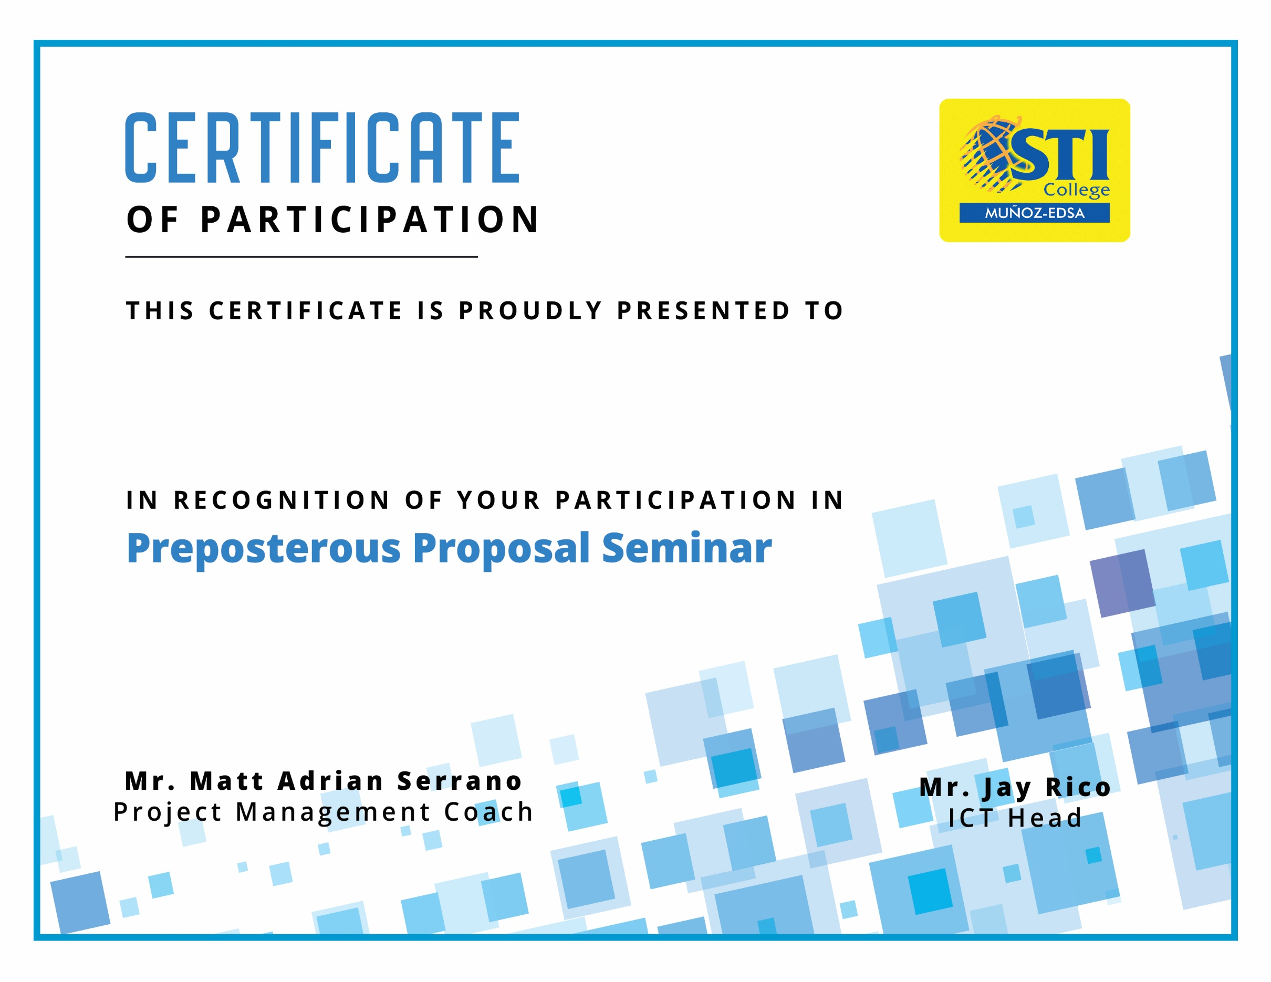

**adssdsa asdas asdas**

**GIVEN ON THIS 17TH OF October, 2019**